A

Project Report

on

**Stock Inventory Management System**

Developed by

**Otha Adil Dinmahmad - Department of IT, DDUniversity**

**Guided By**

**Internal Guide:**

**Prof. Sunil K. Vithlani**

**Department of Information Technology**

**Faculty of Technology**

**DD University**



**Department of Information Technology**

**Faculty of Technology, Dharmsinh Desai University**

**College Road, Nadiad-387001**

**October-2019**

1. TABLE OF CONTENTS
3. **I. Certificate I**
4. **II. Acknowledgement II**
5. **1. SYSTEM OVERVIEW 1**
6. **2. E-R DIAGRAM 2**
7. 2.1 Entities 3
8. 2.2 Relationships 3
9. 2.3 Mapping Constraints 3
10. **3. DATA DICTIONARY 4**
11. **4. SCHEMA DIAGRAM 11**
12. **5. DATABASE IMPLEMENTION 12**
13. 5.1 Create Schema 12
14. 5.2 Insert Queries 17
15. 5.3 Queries (Based on functions, group by, having, joins, sub query etc.) 23
16. 5.4 PL/SQL Blocks (Procedures and Functions) 26
17. 5.5 Cursors. 29
18. 5.6 Exceptions 31
19. 5.7 Triggers 33
20. **6. FUTURE ENHANCEMENTS OF THE SYSTEM 35**
21. **7. BIBLIOGRAPHY 36**
22. **8. WEBSITE IMPLEMENTATION 37**

## DHARMSINH DESAI UNIVERSITY

## NADIAD-387001, GUJARAT



## CERTIFICATE

### This is to certify that the project entitled “Stock Inventory Management System” is a bonafied report of the work carried out by

**Mr. *Otha Adil Dinmahmad***, Student ID No: **16ITUBN150**

of Department of Information Technology, semester V, under the guidance and supervision for the subject Database Management System. They were involved in Project training during academic year 2019-2020.

Prof. Sunil K. Vithlani

(Project Guide)

Department of Information Technology,

Faculty of Technology,

Dharmsinh Desai University, Nadiad

Date:

Prof. Vipul Dabhi

Head , Department of Information Technology,

Faculty of Technology,

Dharmsinh Desai University, Nadiad

## Date:

**ACKNOWLEDGEMENT**

This Project being the first undertaken by us and it was unforgettable and educative experience.We take this oppurtunity to thank all those who have generously helped us to give a proper shape to our project.

Our Sincerest Appreciation Must Be Extended To DDIT, Nadiad. We Also Want To Thanks Faculties Of The College, They Have Been Very Kind & Helpful To Us.

We are thankful To Prof. Sunil K. Vithlani  for giving valuable and constructive suggestions during the planning and development of this Project.

**1. SYSTEM OVERVIEW**

**1.1 OBJECTIVES OF PROPOSED SYSTEM**

Stock Inventory Management System is a software system for tracking inventory levels, orders, sales and deliveries of an E-Commerce Website.

1. To Display detailed information about products like Name, Category, Date of Purchase, Received Quantity, Supplier Name, Remaining Stock, Original Cost, Selling Cost, Availability.
2. To Display detailed information of Students who either ordered a Product or uploaded a Study Material(Notes).
3. To Display detailed information of Notes like Subject, Sessional No, Branch, etc.
4. To Display information about Kits which consist of multiple Products.
5. To Display detailed information about orders like ordered date, quantity, grand total, paid amount, due amount, payment status, delivery status.
6. To dynamically change the In Stock and Availability data in Product table as orders are placed in Orders table.
7. To dynamically get Grand Total bill and Due Amount for an order placed by a Student according to his Ordered Quantity and Paid Amount and set his Payment Status according to it.
8. To dynamically get Total Bill of Products according to the Supplier Name of Products.
9. To dynamically get Total Number of Available Products.
10. To dynamically get Total Ordered Quantity of each individual Product.
11. To dynamically get the Notes as uploaded by the Student and the number of Notes uploaded by him/her.
12. To dynamically get Availability of a Kit according to the Availability of its individual Kit Contents.
13. To dynamically get List of Products which are UnderStocked.
14. To dynamically set Discount to Products whose Selling Cost is higher than a particular amount.
15. To dynamically get List of Students whose Payment is pending or whose Orders are pending.
16. To remove an individual Product from a Kit.

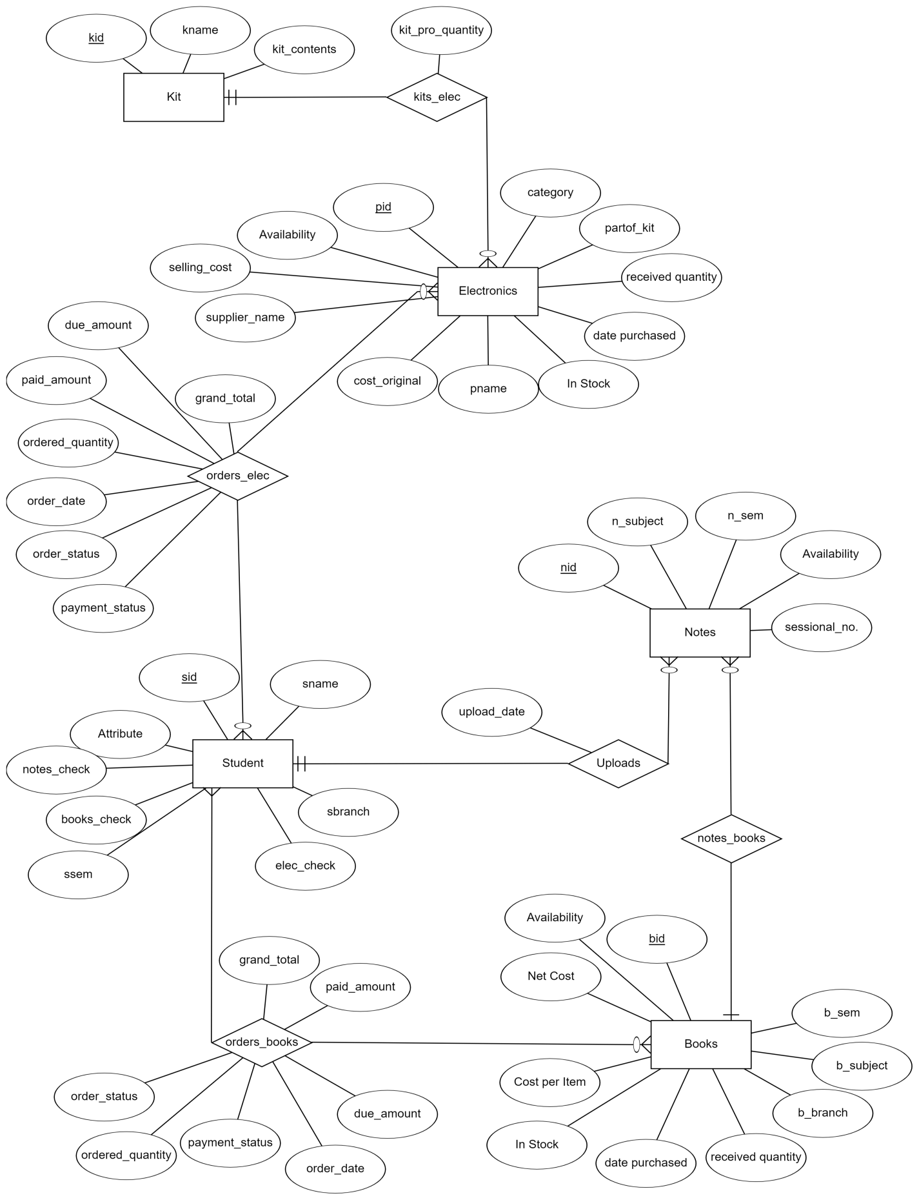**2. E-R DIAGRAM**

Fig 2.1 E-R Diagram Of Stock Inventory Management System

* 1. Entities
* Student
* Electronics
* Books
* Notes
* Kits
  1. Relationships
* orders_elec
* orders_books
* uploads
* kits_elec
  1. Mapping Constraints

1 to Many :- Notes and Books

Notes and Student

Many to Many:- Student and Electronics

Student and Books

Electonics and Kits

**3. DATA DICTIONARY**

## books

|  |  |  |  |  |  |
| --- | --- | --- | --- | --- | --- |
| **Column** | **Type** | **Null** | **Default** | **Links to** | **Comments** |
| bid (Primary) | varchar(10) | No |  |  |  |
| b_name | varchar(255) | No |  |  |  |
| b_branch | varchar(3) | No |  |  |  |
| b_sem | int(2) | No |  |  |  |
| b_subject | varchar(30) | No |  |  |  |
| received_quantity | int(3) | No |  |  |  |
| date_purchased | date | No |  |  |  |
| in_stock | int(3) | No |  |  |  |
| cost_original | int(4) | No |  |  |  |
| selling_cost | int(4) | No |  |  |  |
| supplier_name | varchar(30) | No |  |  |  |
| availability | tinyint(1) | No |  |  |  |

### Indexes

| **Keyname** | **Type** | **Unique** | **Packed** | **Column** | **Cardinality** | **Collation** | **Null** | **Comment** |
| --- | --- | --- | --- | --- | --- | --- | --- | --- |
| PRIMARY | BTREE | Yes | No | bid | 10 | A | No |  |

## electronics

|  |  |  |  |  |  |
| --- | --- | --- | --- | --- | --- |
| **Column** | **Type** | **Null** | **Default** | **Links to** | **Comments** |
| pid (Primary) | varchar(10) | No |  |  |  |
| pname | varchar(30) | No |  |  |  |
| category | varchar(30) | No |  |  |  |
| partof_kit | tinyint(1) | No |  |  |  |
| received_quantity | int(3) | Yes | *NULL* |  |  |
| date_purchased | date | No |  |  |  |
| in_stock | int(3) | Yes | *NULL* |  |  |
| cost_original | int(3) | No |  |  |  |
| selling_cost | int(4) | No |  |  |  |
| supplier_name | varchar(30) | No |  |  |  |
| availability | tinyint(1) | No |  |  |  |

### Indexes

| **Keyname** | **Type** | **Unique** | **Packed** | **Column** | **Cardinality** | **Collation** | **Null** | **Comment** |
| --- | --- | --- | --- | --- | --- | --- | --- | --- |
| PRIMARY | BTREE | Yes | No | pid | 13 | A | No |  |

## kits

|  |  |  |  |  |  |
| --- | --- | --- | --- | --- | --- |
| **Column** | **Type** | **Null** | **Default** | **Links to** | **Comments** |
| kid (Primary) | varchar(10) | No |  |  |  |
| kname | varchar(30) | No |  |  |  |
| kit_contents | varchar(255) | No |  |  |  |

### Indexes

| **Keyname** | **Type** | **Unique** | **Packed** | **Column** | **Cardinality** | **Collation** | **Null** | **Comment** |
| --- | --- | --- | --- | --- | --- | --- | --- | --- |
| PRIMARY | BTREE | Yes | No | kid | 10 | A | No |  |

## kits_elec

|  |  |  |  |  |  |
| --- | --- | --- | --- | --- | --- |
| **Column** | **Type** | **Null** | **Default** | **Links to** | **Comments** |
| kid (Primary) | varchar(10) | No |  | kits -> kid |  |
| pid (Primary) | varchar(10) | No |  | electronics -> pid |  |
| kit_pro_quantity | int(4) | No |  |  |  |

### Indexes

| **Keyname** | **Type** | **Unique** | **Packed** | **Column** | **Cardinality** | **Collation** | **Null** | **Comment** |
| --- | --- | --- | --- | --- | --- | --- | --- | --- |
| PRIMARY | BTREE | Yes | No | kid | 6 | A | No |  |
| pid | 6 | A | No |
| pid | BTREE | No | No | pid | 6 | A | No |  |

## notes

|  |  |  |  |  |  |
| --- | --- | --- | --- | --- | --- |
| **Column** | **Type** | **Null** | **Default** | **Links to** | **Comments** |
| nid (Primary) | varchar(10) | No |  |  |  |
| bid | varchar(10) | No |  | books -> bid |  |
| n_branch | varchar(10) | No |  |  |  |
| n_subject | varchar(30) | No |  |  |  |
| n_sem | int(3) | No |  |  |  |
| sessional_no. | int(1) | Yes | *NULL* |  |  |
| availability | tinyint(1) | No |  |  |  |

### Indexes

| **Keyname** | **Type** | **Unique** | **Packed** | **Column** | **Cardinality** | **Collation** | **Null** | **Comment** |
| --- | --- | --- | --- | --- | --- | --- | --- | --- |
| PRIMARY | BTREE | Yes | No | nid | 10 | A | No |  |
| bid | BTREE | No | No | bid | 10 | A | No |  |

## uploads

|  |  |  |  |  |  |
| --- | --- | --- | --- | --- | --- |
| **Column** | **Type** | **Null** | **Default** | **Links to** | **Comments** |
| nid (Primary) | varchar(10) | No |  | notes -> nid |  |
| sid | varchar(10) | No |  | student -> sid |  |
| upload_date | date | No |  |  |  |

### Indexes

| **Keyname** | **Type** | **Unique** | **Packed** | **Column** | **Cardinality** | **Collation** | **Null** | **Comment** |
| --- | --- | --- | --- | --- | --- | --- | --- | --- |
| PRIMARY | BTREE | Yes | No | nid | 6 | A | No |  |
| sid | BTREE | No | No | sid | 6 | A | No |  |

## orders_books

|  |  |  |  |  |  |
| --- | --- | --- | --- | --- | --- |
| **Column** | **Type** | **Null** | **Default** | **Links to** | **Comments** |
| obid *(Primary)* | varchar(10) | No |  |  |  |
| sid | varchar(10) | No |  | student -> sid |  |
| bid | varchar(10) | No |  | books -> bid |  |
| order_date | date | No |  |  |  |
| ordered_quantity | int(11) | Yes |  |  |  |
| grand_total | int(11) | Yes |  |  |  |
| paid_amount | int(11) | Yes |  |  |  |
| due_amount | int(11) | Yes |  |  |  |
| payment_status | tinyint(1) | Yes |  |  |  |
| order_status | tinyint(1) | Yes |  |  |  |

### Indexes

| **Keyname** | **Type** | **Unique** | **Packed** | **Column** | **Cardinality** | **Collation** | **Null** | **Comment** |
| --- | --- | --- | --- | --- | --- | --- | --- | --- |
| PRIMARY | BTREE | Yes | No | sid | 3 | A | No |  |
| bid | 3 | A | No |
| bid | BTREE | No | No | bid | 3 | A | No |  |

## orders_elec

|  |  |  |  |  |  |
| --- | --- | --- | --- | --- | --- |
| **Column** | **Type** | **Null** | **Default** | **Links to** | **Comments** |
| oeid (Primary) | varchar(10) | No |  |  |  |
| sid | varchar(10) | No |  | student -> sid |  |
| pid | varchar(10) | No |  | electronics -> pid |  |
| order_date | date | No |  |  |  |
| ordered_quantity | int(11) | No |  |  |  |
| grand_total | int(11) | No |  |  |  |
| paid_amount | int(11) | No |  |  |  |
| due_amount | int(11) | No |  |  |  |
| payment_status | tinyint(1) | No |  |  |  |
| order_status | tinyint(1) | No |  |  |  |

## Indexes

| **Keyname** | **Type** | **Unique** | **Packed** | **Column** | **Cardinality** | **Collation** | **Null** | **Comment** |
| --- | --- | --- | --- | --- | --- | --- | --- | --- |
| PRIMARY | BTREE | Yes | No | oeid | 6 | A | No |  |
| sid | BTREE | No | No | sid | 6 | A | No |  |
| pid | BTREE | No | No | pid | 6 | A | No |  |

## student

|  |  |  |  |  |  |
| --- | --- | --- | --- | --- | --- |
| **Column** | **Type** | **Null** | **Default** | **Links to** | **Comments** |
| sid (Primary) | varchar(10) | No |  |  |  |
| sname | varchar(30) | No |  |  |  |
| sbranch | varchar(30) | No |  |  |  |
| ssem | int(1) | No |  |  |  |
| elec_check | tinyint(1) | No |  |  |  |
| books_check | tinyint(1) | No |  |  |  |
| notes_check | tinyint(1) | No |  |  |  |

## Indexes

| **Keyname** | **Type** | **Unique** | **Packed** | **Column** | **Cardinality** | **Collation** | **Null** | **Comment** |
| --- | --- | --- | --- | --- | --- | --- | --- | --- |
| PRIMARY | BTREE | Yes | No | sid | 10 | A | No |  |

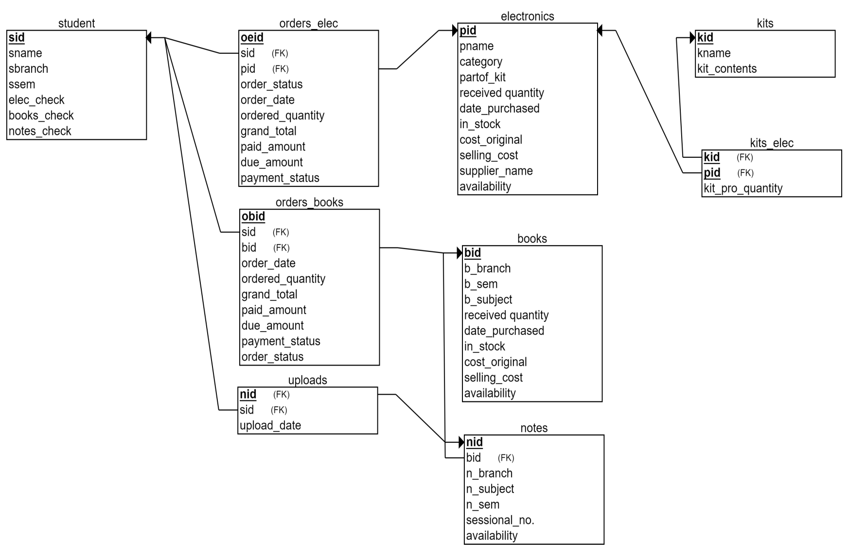**4. SCHEMA DIAGRAM**

Fig 4.1 Schema Diagram Of Stock Inventory Management System

**5. DATABASE IMPLEMENTION**

**5.1 CREATE SCHEMA**

CREATE TABLE `books` (

`bid` varchar(10) NOT NULL,

`b_name` varchar(255) NOT NULL,

`b_branch` varchar(3) NOT NULL,

`b_sem` int(2) NOT NULL,

`b_subject` varchar(30) NOT NULL,

`received_quantity` int(3) NOT NULL,

`date_purchased` date NOT NULL,

`in_stock` int(3) NOT NULL,

`cost_original` int(4) NOT NULL,

`selling_cost` int(4) NOT NULL,

`supplier_name` varchar(30) NOT NULL,

`availability` tinyint(1) NOT NULL

) ;

CREATE TABLE `electronics` (

`pid` varchar(10) NOT NULL,

`pname` varchar(30) NOT NULL,

`category` varchar(30) NOT NULL,

`partof_kit` tinyint(1) NOT NULL,

`received_quantity` int(3) DEFAULT NULL,

`date_purchased` date NOT NULL,

`in_stock` int(3) DEFAULT NULL,

`cost_original` int(3) NOT NULL,

`selling_cost` int(4) NOT NULL,

`supplier_name` varchar(30) NOT NULL,

`availability` tinyint(1) NOT NULL

);

CREATE TABLE `kits` (

`kid` varchar(10) NOT NULL,

`kname` varchar(30) NOT NULL,

`kit_contents` varchar(255) NOT NULL

);

CREATE TABLE `kits_elec` (

`kid` varchar(10) NOT NULL,

`pid` varchar(10) NOT NULL,

`kit_pro_quantity` int(4) NOT NULL

);

CREATE TABLE `notes` (

`nid` varchar(10) NOT NULL,

`bid` varchar(10) NOT NULL,

`n_branch` varchar(10) NOT NULL,

`n_subject` varchar(30) NOT NULL,

`n_sem` int(3) NOT NULL,

`sessional_no.` int(1) DEFAULT NULL,

`availability` tinyint(1) NOT NULL

);

CREATE TABLE `orders_books` (

`obid` varchar(10) NOT NULL,

`sid` varchar(10) NOT NULL,

`bid` varchar(10) NOT NULL,

`order_date` date NOT NULL,

`ordered_quantity` int(11) DEFAULT NULL,

`grand_total` int(11) DEFAULT NULL,

`paid_amount` int(11) DEFAULT NULL,

`due_amount` int(11) DEFAULT NULL,

`payment_status` tinyint(1) DEFAULT NULL,

`order_status` tinyint(1) DEFAULT NULL

);

CREATE TABLE `orders_elec` (

`oeid` varchar(10) NOT NULL,

`sid` varchar(10) NOT NULL,

`pid` varchar(10) NOT NULL,

`order_date` date NOT NULL,

`ordered_quantity` int(11) NOT NULL,

`grand_total` int(11) NOT NULL,

`paid_amount` int(11) NOT NULL,

`due_amount` int(11) NOT NULL,

`payment_status` tinyint(1) NOT NULL,

`order_status` tinyint(1) NOT NULL

);

CREATE TABLE `student` (

`sid` varchar(10) NOT NULL,

`sname` varchar(30) NOT NULL,

`sbranch` varchar(30) NOT NULL,

`ssem` int(1) NOT NULL,

`elec_check` tinyint(1) NOT NULL,

`books_check` tinyint(1) NOT NULL,

`notes_check` tinyint(1) NOT NULL

);

CREATE TABLE `uploads` (

`nid` varchar(10) NOT NULL,

`sid` varchar(10) NOT NULL,

`upload_date` date NOT NULL

);

**OUTPUT OF DESC QUERIES**

DESC books

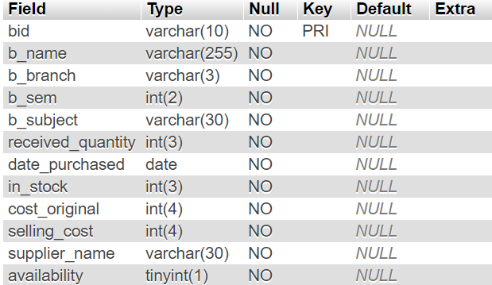

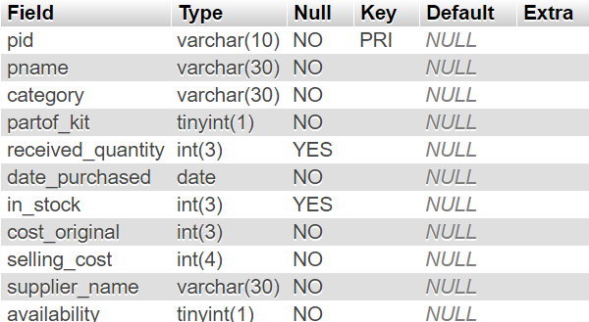DESC electronics

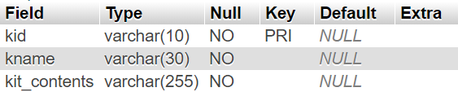DESC kits

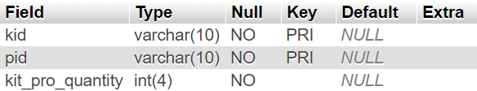DESC kits_elec

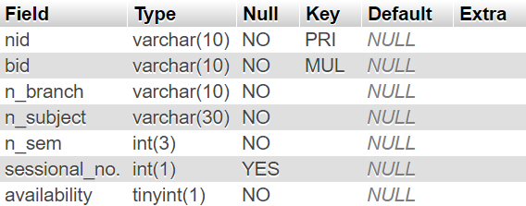DESC notes

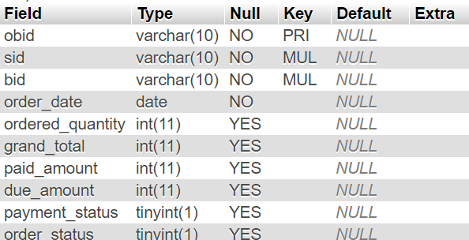DESC orders_books

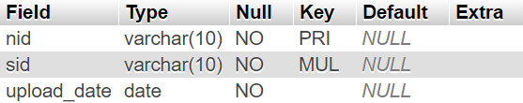DESC uploads

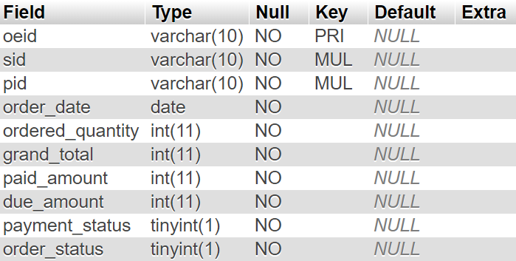DESC orders_elec

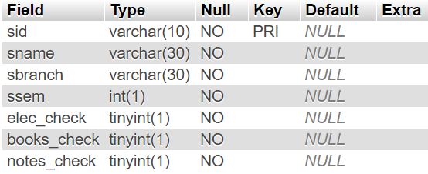DESC student

**5.2 INSERT DATA VALUES**

[INSERT](http://localhost/phpmyadmin/url.php?url=https://dev.mysql.com/doc/refman/5.5/en/insert.html) INTO `books` (`bid`, `b_name`, `b_branch`, `b_sem`, `b_subject`, `received_quantity`, `date_purchased`, `in_stock`, `cost_original`, `selling_cost`, `supplier_name`, `availability`) [VALUES](http://localhost/phpmyadmin/url.php?url=https://dev.mysql.com/doc/refman/5.5/en/miscellaneous-functions.html#function_values) ('b001', 'Discreet Maths by CL Liu', 'IT', '3', 'DM', '5', '2019-08-19', '4', '300', '250', 'sooraj_anand', '1'), ('b002', 'DBMS by Korth', 'CE', '3', 'DBMS', '8', '2019-10-03', '5', '400', '350', 'lovely_vadodara', '1'), ('b003', 'DDC by Moris Mano', 'IT', '3', 'DDC', '6', '2019-08-19', '0', '500', '300', 'sooraj_anand', '0'), ('b004', 'Learning Angular by Brad Dayley', 'CE', '5', 'AngularJS', '3', '2019-08-26', '0', '300', '250', 'lovely_vadodara', '0'), ('b005', 'Head First Java by Bert Bates', 'IT', '5', 'CJT', '3', '2019-08-26', '1', '200', '150', 'sooraj_anand', '1'), ('b006', 'AMP by Douglas', 'IT', '5', 'AMP', '5', '2019-08-26', '1', '500', '450', 'lovely_vadodara', '1'), ('b007', 'CCN by Forouzan', 'IT', '3', 'CCN', '6', '2019-08-26', '2', '400', '350', 'sooraj_anand', '1'), ('b008', 'DAA by Corman', 'IT', '5', 'DAA', '3', '2019-08-19', '0', '200', '150', 'lovely_vadodara', '0'), ('b009', 'Engineering Drawing by ND Bhatt', 'MH', '1', 'Engineering Graphics', '5', '2019-08-19', '0', '250', '200', 'lovely_vadodara', '0'), ('b011', 'Data Structures and Algorithms by Sartaj Sahni', 'IT', '4', 'DSA ', '5', '2019-09-10', '0', '500', '400', 'sooraj_anand', '0');

[INSERT](http://localhost/phpmyadmin/url.php?url=https://dev.mysql.com/doc/refman/5.5/en/insert.html) INTO `electronics` (`pid`, `pname`, `category`, `partof_kit`, `received_quantity`, `date_purchased`, `in_stock`, `cost_original`, `selling_cost`, `supplier_name`, `availability`) [VALUES](http://localhost/phpmyadmin/url.php?url=https://dev.mysql.com/doc/refman/5.5/en/miscellaneous-functions.html#function_values) ('p001', '5V Adaptor', 'Basic Components', '0', '10', '2019-08-26', '2', '150', '140', 'lovely_vadodara', '1'), ('p002', 'Heat Sink', 'Basic Components', '0', '15', '2019-08-26', '15', '15', '10', 'lovely_vadodara', '1'), ('p003', 'Banana Pins', 'Basic Components', '0', '20', '2019-08-26', '15', '20', '10', 'lovely_vadodara', '0'), ('p004', 'Crocodile Pins', 'Basic Components', '0', '30', '2019-08-26', '20', '20', '10', 'sooraj_anand', '0'), ('p006', 'LiPo Charger', 'Basic Components', '0', '5', '2019-07-15', '1', '650', '630', 'sooraj_anand', '1'), ('p007', 'Basic Electronics Kit', 'Kits', '0', NULL, '2019-08-26', NULL, '570', '449', 'lovely_vadodara', '1'), ('p008', 'Connecting Wires', 'Basic Components', '1', '20', '2019-08-26', '15', '35', '27', 'sooraj_anand', '1'), ('p009', 'Resistor Box', 'Basic Components', '1', '15', '2019-08-26', '10', '35', '27', 'lovely_vadodara', '0'), ('p010', 'Breadboard', 'Basic Components', '1', '25', '2019-08-26', '20', '90', '65', 'sooraj_anand', '1'), ('p011', 'Transformer', 'Basic Components', '1', '5', '2019-09-10', '10', '150', '130', 'lovely_vadodara', '1'), ('p012', 'PCB', 'Basic Components', '1', '15', '2019-09-10', '15', '200', '150', 'lovely_vadodara', '1'), ('p013', 'Capacitor', 'Basic Components', '1', '30', '2019-09-10', '15', '10', '5', 'lovely_vadodara', '1'), ('p014', 'Kit for Variable Power Supply', 'Kits', '0', NULL, '2019-09-10', NULL, '300', '290', 'lovely_vadodara', '1')

[INSERT](http://localhost/phpmyadmin/url.php?url=https://dev.mysql.com/doc/refman/5.5/en/insert.html) INTO `kits` (`kid`, `kname`, `kit_contents`) [VALUES](http://localhost/phpmyadmin/url.php?url=https://dev.mysql.com/doc/refman/5.5/en/miscellaneous-functions.html#function_values) ('k001', 'Basic Electronics Kit', 'Breadboard, Connecting Wires, Resistor Box'), ('k002', 'Kit For Variable Power Supply', '12-0-12 transformer*4 x 6 inch PCB*Capacitor x 3 (10uf, 100uf, 1000uf)*Connecting wires*Diode x 6*Potentiometer*Voltage regulator IC 7805*LM317 IC*LED'), ('k003', 'Robot Kit For Beginners', 'Two wheels metal chassis body*DC motor x 2*rubber coated wheels x 2*caster wheel*PCB*9V batteries with cap x 2*ive volt regulator IC*IR sensor*AND,OR,NOT gate ic*L293D module*Male Header*f2f and m2f jumper pin'), ('k004', 'Tool Kit', 'Soldering Wire*Solder Iron* Cutter*Double-sided tape-Screwdriver kit'), ('k005', 'Play with Arduino Kit', 'RGB led*Jumper wires m2m,m2f*Buzzer*Arduino with cable* Ultrasonic*LCD display*Potentiometer*Push switch*9v battery*LDR*Jack cable'), ('k006', 'Fingerprint Sensor GT511C3', 'Fingerprint Sensor*Wires'), ('k007', 'Engineering Graphics Kit', 'Mini Drafter (Omega)*Set Squares*Rounder Compass*Drawing Board Clips*Protractor*Ruler*Master circle'), ('k008', 'The Radar Kit', 'Servo Motor : 1x*\r\nSonic Sensor : 1x*\r\nJumper Cables : F2F 10x | M2M 10x\r\n'), ('k009', 'Constant Power Supply Kit', '12-0-12 transformer*\r\n4 x 6 inch PCB*\r\nCapacitor x 3 (10uf, 100uf, 1000uf)*\r\nConnecting wires*\r\nDiode x 6*\r\nVoltage regulator IC 7805*\r\nLM317 IC*\r\nLED'), ('k010', 'Capacitor Bank', '0.1uF X 2*1uF X 2*10uF X 2*100uF X 2')

[INSERT](http://localhost/phpmyadmin/url.php?url=https://dev.mysql.com/doc/refman/5.5/en/insert.html) INTO `notes` (`nid`, `bid`, `n_branch`, `n_subject`, `n_sem`, `sessional_no.`, `availability`) [VALUES](http://localhost/phpmyadmin/url.php?url=https://dev.mysql.com/doc/refman/5.5/en/miscellaneous-functions.html#function_values) ('n001', 'b001', 'IT', 'DM', '3', '2', '1'), ('n002', 'b011', 'CE', 'DSA', '3', '1', '0'), ('n003', 'b009', 'MH', 'EG', '1', '2', '1'), ('n004', 'b007', 'IT', 'CCN', '3', '3', '0'), ('n005', 'b004', 'CE', 'Angular JS', '5', '3', '1'), ('n006', 'b003', 'IT', 'DDC', '6', '1', '0'), ('n007', 'b002', 'CE', 'DBMS', '5', NULL, '1'), ('n008', 'b005', 'IT', 'CJT', '3', NULL, '0'), ('n009', 'b008', 'IT', 'DAA', '6', '2', '1'), ('n010', 'b006', 'IT', 'AMP', '5', '3', '1')

[INSERT](http://localhost/phpmyadmin/url.php?url=https://dev.mysql.com/doc/refman/5.5/en/insert.html) INTO `student` (`sid`, `sname`, `sbranch`, `ssem`, `elec_check`, `books_check`, `notes_check`) [VALUES](http://localhost/phpmyadmin/url.php?url=https://dev.mysql.com/doc/refman/5.5/en/miscellaneous-functions.html#function_values) ('s001', 'Adil', 'IT', '5', '1', '0', '1'), ('s002', 'Himanshu', 'CE', '5', '1', '0', '0'), ('s003', 'Sameep', 'MH', '3', '0', '1', '0'), ('s004', 'Devanshu', 'IT', '5', '0', '1', '1'), ('s005', 'Meet', 'CL', '7', '0', '0', '1'), ('s006', 'Kush', 'EC', '1', '0', '1', '0'), ('s007', 'Ramya', 'CE', '4', '1', '0', '0'), ('s008', 'Tejas', 'IC', '5', '0', '1', '0'), ('s009', 'Khilan', 'CE', '6', '1', '1', '1')

[INSERT](http://localhost/phpmyadmin/url.php?url=https://dev.mysql.com/doc/refman/5.5/en/insert.html) INTO `kits_elec` (`kid`, `pid`, `kit_pro_quantity`) [VALUES](http://localhost/phpmyadmin/url.php?url=https://dev.mysql.com/doc/refman/5.5/en/miscellaneous-functions.html#function_values) ('k001', 'p008', '4'), ('k001', 'p009', '2'), ('k001', 'p010', '1'), ('k002', 'p011', '1'), ('k002', 'p012', '1'), ('k002', 'p013', '10');

[INSERT](http://localhost/phpmyadmin/url.php?url=https://dev.mysql.com/doc/refman/5.5/en/insert.html) INTO `orders_books` (`obid`, `sid`, `bid`, `order_date`, `ordered_quantity`, `grand_total`, `paid_amount`, `due_amount`, `payment_status`, `order_status`)

[VALUES](http://localhost/phpmyadmin/url.php?url=https://dev.mysql.com/doc/refman/5.5/en/miscellaneous-functions.html#function_values) ('ob001', 's001', 'b001', '2019-08-05', '1', '250', '250', '0', '1', '1'), ('ob002', 's001', 'b002', '2019-08-05', '2', '660', '600', '60', '0', '1'), ('ob003', 's002', 'b003', '2019-08-06', '2', '600', '600', '0', '1', '1'), ('ob004', 's002', 'b006', '2019-10-11', '2', '800', '400', '400', '0', '1'), ('ob005', 's002', 'b001', '2019-10-17', '1', '250', '200', '50', '0', '1'), ('ob006', 's001', 'b001', '2019-10-17', '1', '250', '250', '0', '1', '1')

[INSERT](http://localhost/phpmyadmin/url.php?url=https://dev.mysql.com/doc/refman/5.5/en/insert.html) INTO `orders_elec` (`oeid`, `sid`, `pid`, `order_date`, `ordered_quantity`, `grand_total`, `paid_amount`, `due_amount`, `payment_status`, `order_status`)

[VALUES](http://localhost/phpmyadmin/url.php?url=https://dev.mysql.com/doc/refman/5.5/en/miscellaneous-functions.html#function_values) ('oe001', 's001', 'p003', '2019-08-07', '1', '10', '10', '0', '1', '1'), ('oe002', 's003', 'p010', '2019-08-08', '2', '130', '120', '10', '0', '1'), ('oe003', 's004', 'p001', '2019-08-07', '2', '280', '280', '0', '1', '1'), ('oe004', 's005', 'p003', '2019-08-07', '19', '190', '100', '90', '0', '1'), ('oe005', 's001', 'p001', '2019-10-17', '1', '140', '100', '40', '0', '1'), ('oe006', 's002', 'p010', '2019-10-17', '1', '65', '65', '0', '1', '1')

**OUTPUT OF SELECT * QUERIES**

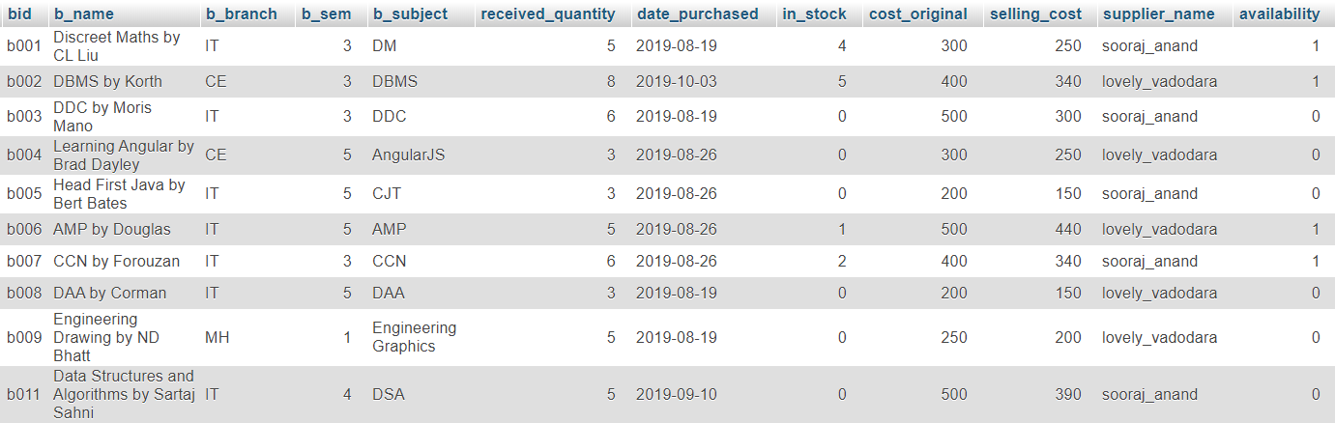SELECT * FROM books

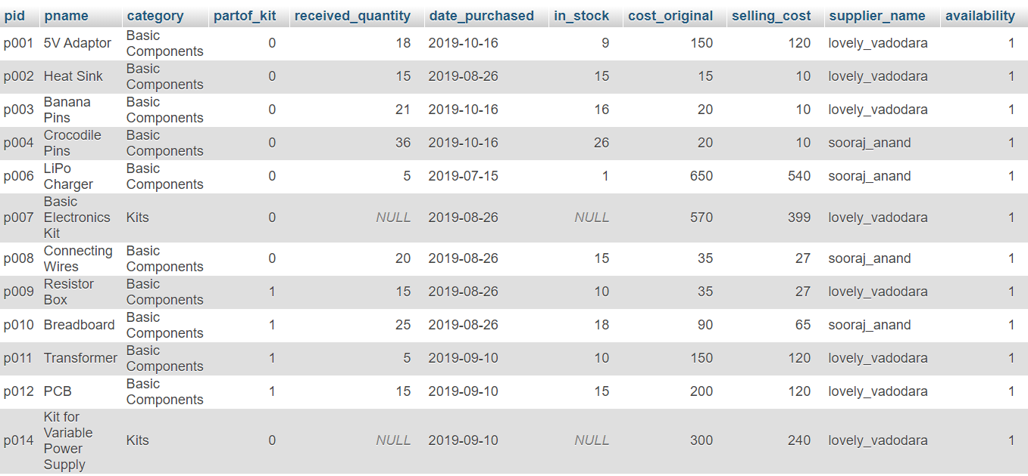SELECT * FROM electronics

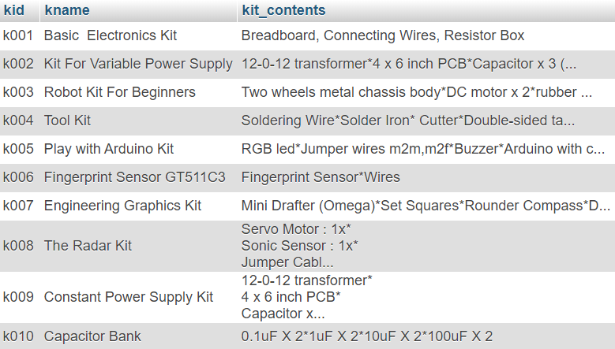SELECT * FROM kits

SELECT * FROM kits_elec

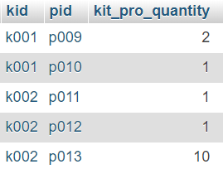

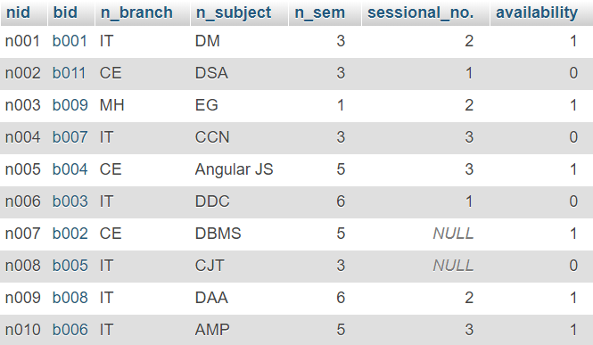SELECT * FROM notes

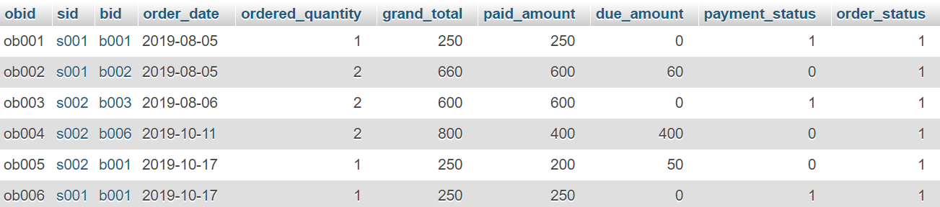SELECT * FROM orders_books

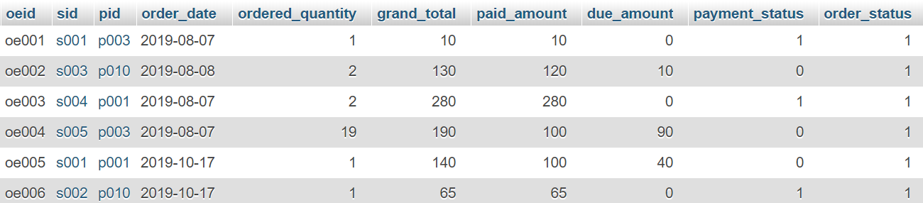SELECT * FROM orders_elec

SELECT * FROM student

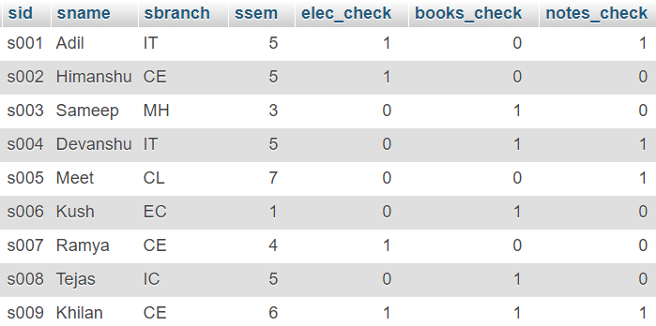

SELECT * FROM uploads

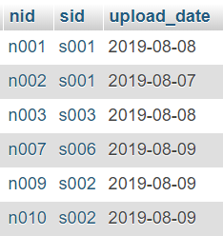

**5.3 QUERIES (BASED ON FUNCTIONS, GROUP BY, HAVING, JOINS, SUB QUERY ETC.)**

1. Display name of Students whose Payment is pending:-

SELECT s.sid,s.sname FROM student s INNER JOIN orders_books o ON s.sid=o.sid WHERE o.payment_status=0;

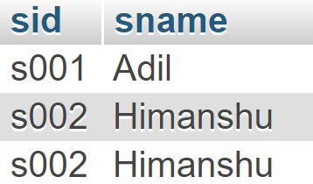

2. Display Student wise Notes:-

SELECT s.sid,s.sname,u.nid,n1.n_subject FROM uploads u INNER JOIN student s ON u.sid=s.sid INNER JOIN notes n1 ON u.nid=n1.nid

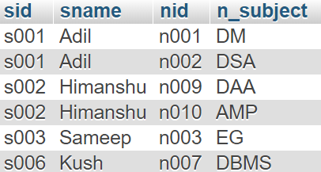

3. Find Total Ordered Quantity of every Electronic product:-

SELECT o.pid,e.pname,SUM(o.ordered_quantity) FROM orders_elec o inner join electronics e on o.pid=e.pid group by o.pid,e.pname;

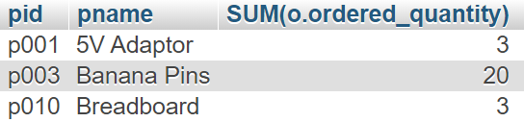

4. Find Kits which are Available in Stock:-

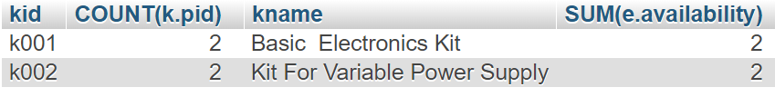select k.kid,COUNT(k.pid),k1.kname,SUM(e.availability) from kits_elec k inner join electronics e on k.pid=e.pid inner join kits k1 on k.kid=k1.kid group by k.kid,k1.kname having(COUNT(k.pid)=SUM(e.availability));

5. Find total number of Available Books:-

Select COUNT(availability) from books;

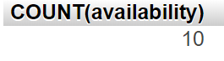

6. Find total cost of Available Books:-

Select SUM(in_stock*selling_cost) from books where availability=1;

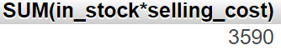

7. Find all students whose orders are delivered(1)/pending(0)

[specified by boolean value]:-

Select o.sid,s.sname,o.order_status from orders_elec o inner join student s on o.sid=s.sid where o.order_status=1;

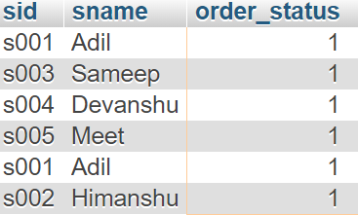

8. Find number of Notes submitted by each Student:-

Select u.sid,s.sname,COUNT(u.nid) from uploads u inner join student s on u.sid=s.sid group by u.sid;

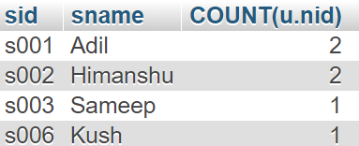

9. Find Supplier wise Bill:-

Select supplier_name,SUM(received_quantity*cost_original) from electronics group by supplier_name;

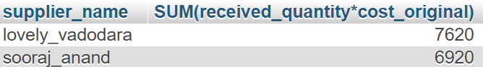

10. Display Students who ordered Kits:-

Select s.sname,s.ssem,s.sbranch from student s inner join orders_elec o on s.sid=o.sid where o.pid in(select pid from electronics where category ='kits');

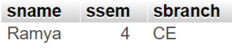

**5.4 PL/SQL BLOCKS (Procedures and Functions)**

1. Procedure to Set Grand Total, Due Amount and Payment Status in Book Orders:-

PARAMETERS:

IN: orderid VARCHAR(10),

OUT: grandtotal INT, da INT, ps INT

BEGIN

DECLARE gt INT;

-- call the function

SET grandtotal = getGrandTotal_books(orderid);

update orders_books set grand_total=grandtotal where obid=orderid;

set da=getDueAmount_books(orderid);

if da=0 then

set ps=1;

update orders_books set due_amount=da, payment_status=1 where obid=orderid;

else

set ps=0;

update orders_books set due_amount=da, payment_status=0 where obid=orderid;

end if;

END

OUTPUT:

2. Procedure to Add Stock to either Books or Electronics depending on ID:-

PARAMETERS:

IN: id, quant, date

BEGIN

DECLARE fchar varchar(1);

DECLARE avail int;

Select substring(id,1,1) into fchar;

if fchar='p' THEN

update electronics set received_quantity=received_quantity+quant,in_stock=in_stock+quant,

date_purchased=date,availability=1 WHERE pid=id;

ELSEIF fchar='b' THEN

update books set received_quantity=received_quantity+quant,in_stock=in_stock+quant,

date_purchased=date, availability=1 WHERE bid=id;

end if;

END

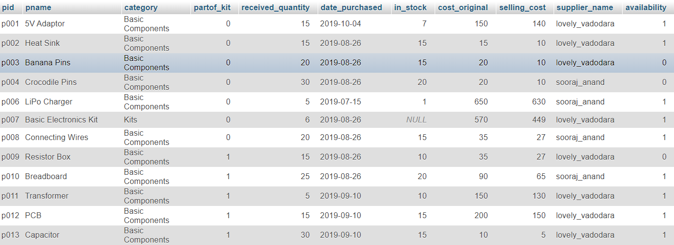OUTPUT:-

3. Function to Return Grand Total to Procedure:-

PARAMETERS:

orderid VARCHAR(10)

BEGIN

DECLARE sc,oq INT;

DECLARE bk VARCHAR(10);

SET bk=orderid;

select b.selling_cost,o.ordered_quantity into sc,oq from books b inner join orders_books o on b.bid=o.bid where o.obid=bk;

-- return the grand total

RETURN (sc*oq);

END

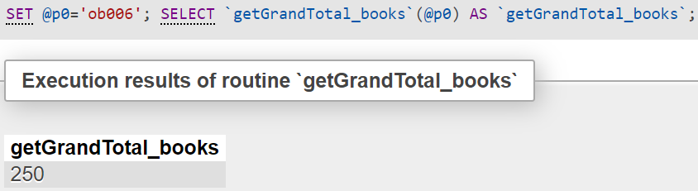

OUTPUT:

4. Function to Return Due Amount to Procedure:-

PARAMETERS:

bookid VARCHAR(10)

stuid VARCHAR(10)

BEGIN

DECLARE pa,gt INT;

DECLARE bk VARCHAR(10);

SET bk=orderid;

Select grand_total,paid_amount into gt,pa from orders_books where obid=orderid;

-- return the due amount

RETURN (gt+(-pa));

END

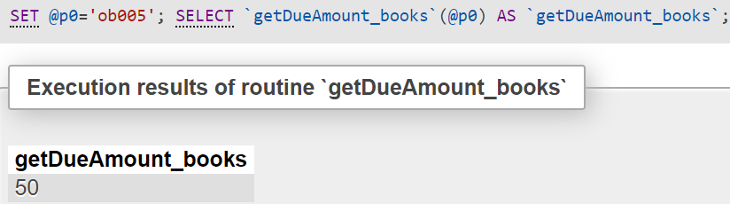OUTPUT:

**5.5 CURSORS**

1. Cursor to Add Products whose Stock is less than 3 to a newly created table:-

BEGIN

DECLARE finished INTEGER DEFAULT 0;

DECLARE c_pName varchar(30) DEFAULT NULL;

DECLARE c_pId varchar(10) DEFAULT NULL;

-- declare cursor for product to be ordered

DECLARE curProduct CURSOR FOR SELECT pid,pname FROM electronics where in_stock<3 and category="Basic Components";

-- declare NOT FOUND handler

DECLARE CONTINUE HANDLER

FOR NOT FOUND SET finished = 1;

CREATE TABLE IF NOT EXISTS `dbms_project`.`restockproducts` ( `id` VARCHAR(10), `name` VARCHAR(30)) ENGINE = InnoDB;

OPEN curProduct;

getProduct: LOOP

FETCH curProduct INTO c_pId,c_pName;

IF finished = 1 THEN

LEAVE getProduct;

END IF;

-- build table of products to be reordered

INSERT INTO `restockproducts` (`id`, `name`) VALUES (c_pId, c_pName);

END LOOP getProduct;

CLOSE curProduct;

END

OUTPUT:

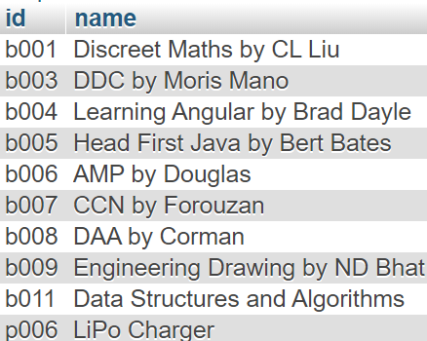

2. Set Discount to all Books whose selling cost is greater than or equal to input value:-

PARAMETERS:

IN: disc INT, aboveVal INT

BEGIN

DECLARE finished INTEGER DEFAULT 0;

DECLARE c_bId varchar(10) DEFAULT NULL;

-- declare cursor

DECLARE curDisc CURSOR FOR SELECT pid FROM electronics where selling_cost>=aboveVal;

-- declare NOT FOUND handler

DECLARE CONTINUE HANDLER

FOR NOT FOUND SET finished = 1;

OPEN curDisc;

getElec: LOOP

FETCH curDisc INTO c_bId;

IF finished = 1 THEN

LEAVE getElec;

END IF;

UPDATE electronics SET selling_cost=selling_cost-disc WHERE pid=c_bID;

END LOOP getElec;

CLOSE curDisc;

END

OUTPUT:

disc=40

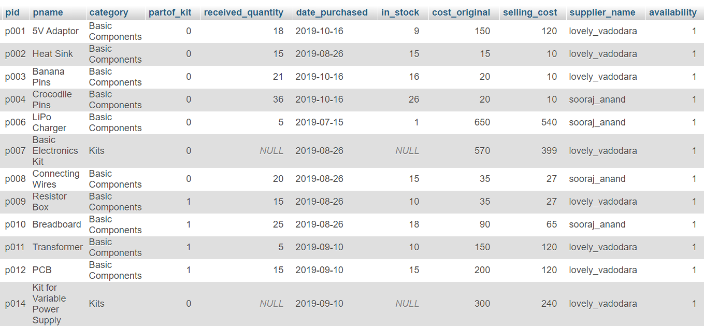aboveVal=500

**5.6 EXCEPTIONS**

1. Cursor to Raise Exception if Negative Paid Amount is entered in Orders:-

BEGIN

DECLARE finished INTEGER DEFAULT 0;

DECLARE c_amt int DEFAULT NULL;

-- declare cursor for product to be ordered

DECLARE curNegCheck CURSOR FOR SELECT paid_amount FROM orders_books;

-- declare NOT FOUND handler

DECLARE CONTINUE HANDLER

FOR NOT FOUND SET finished = 1;

CREATE TABLE IF NOT EXISTS `dbms_project`.`restockproducts` ( `id` VARCHAR(10), `name` VARCHAR(30)) ENGINE = InnoDB;

OPEN curNegCheck;

getAmt: LOOP

FETCH curNegCheck INTO c_amt;

IF finished = 1 THEN

LEAVE getAmt;

END IF;

IF c_amt<0 then

SIGNAL SQLSTATE'45000'

SET MESSAGE_TEXT="Paid Amount cannot be Negative!";

END IF;

END LOOP getAmt;

CLOSE curNegCheck;

END

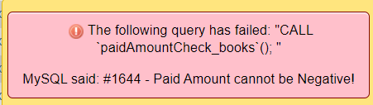OUTPUT:

2. Raise Exception if duplicate primary key entered:-

PARAMETERS:

IN: orderid VARCHAR(10)

BEGIN

-- exit if the duplicate key occurs

DECLARE EXIT HANDLER FOR 1062

BEGIN

SELECT CONCAT('Duplicate key (',orderid,') occurred') AS message;

END;

-- insert a new row into the SupplierProducts

INSERT INTO orders_elec(oeid)

VALUES(orderid);

END

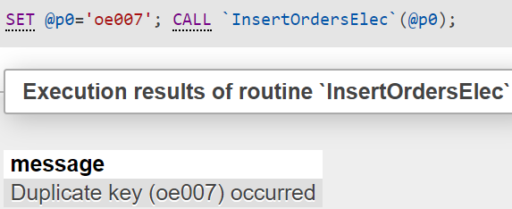OUTPUT:

**5.7 TRIGGERS**

1. Set Trigger to update stock and set availability to 0 if stock is 0:-

TYPE: AFTER INSERT

ON TABLE: orders_elec

begin

declare a INT;

update electronics set in_stock=(in_stock-new.ordered_quantity) where pid=new.pid;

select in_stock into @a from electronics where pid=new.pid;

if @a=0 then

update electronics set availability=0 where pid=new.pid;

end if;

end

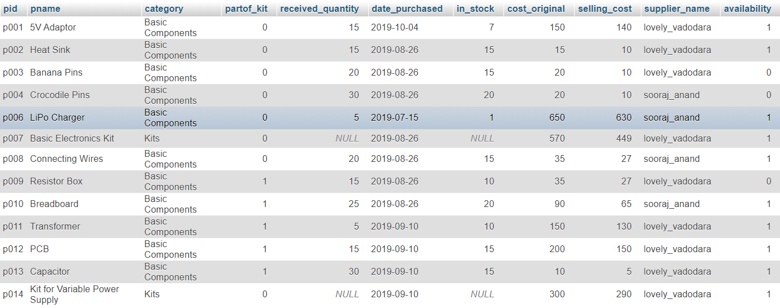OUTPUT:

2. Set Trigger to set part of_kit=0 in electronics table if product is removed from kits table:-

TYPE: AFTER DELETE

ON TABLE: kits_elec

begin

declare a INT;

update electronics set partof_kit=0 where pid=old.pid;

end

OUTPUT:

**6. FUTURE ENHANCEMENTS OF THE SYSTEM**

Furthermore my system can be integrated with third party website through which it can directly get the data and serve as a useful software for the Stock Inventory Managers.

**7. BIBLIOGRAPHY**

For our project we have referred many sources from the Internet for the code snippets, logic tips from various books as well as from websites.

Many of the logics used in our project are indeed provided in textbooks which we have referred and the concepts from these books have helped in making efficient and reliable database system design.

Reference books :-

Data Base System Concepts by Henry F.Korth & A.Silberschatz. 2nd Ed. McGraw-Hill 1991.

SQL, PL/SQL The programming language of Oracle by Ivan Bayross, BPB Publications.

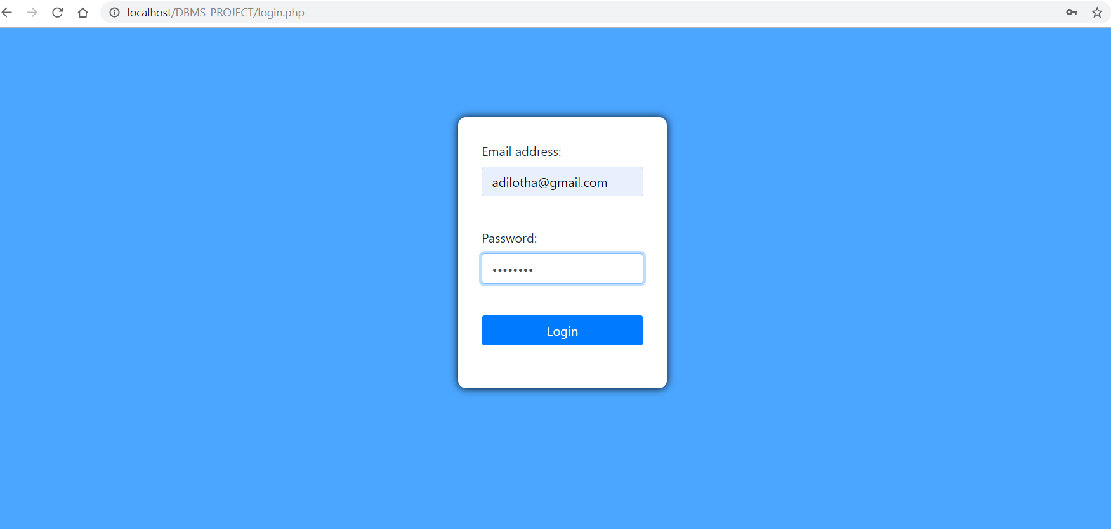**7. WEBSITE IMPLEMENTATION**



